How to make a withdrawal from your Parent Account
1. Go to www.parentpay.com and log into your ParentPay account
2. Navigate to Parent Account
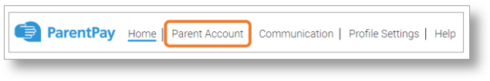
3. Your statement will then be displayed
4. Select Withdraw from beneath the statement
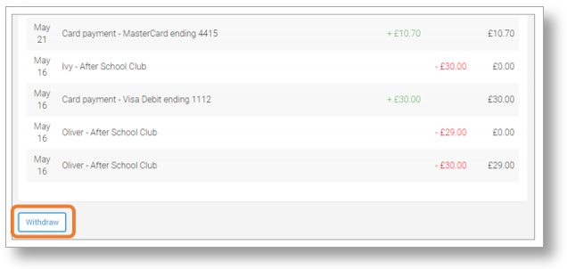
5. Enter the amount to be withdrawn. This can be a minimum of 5p, and a maximum of the total amount in your Parent Account
NOTE: The number of withdrawals may be adjusted at times to assist payers with being able to withdraw allocated funds.
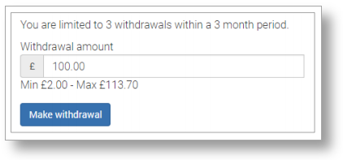
6. Select Make withdrawal
7. Confirm the withdrawal
8. Confirmation of the withdrawal will be displayed.
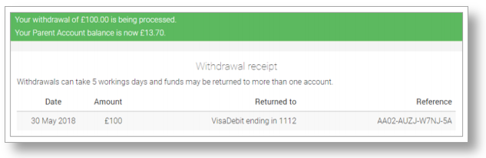
Note: The withdrawal may take up to 5 working days to be credited back to the card/bank account detailed on the withdrawal screen

